Author D. Ed. Hoggatt will visit our classes on [insert visit date].

Mr. Hoggatt is a former newspaper editor, and he is an award-winning teacher with 24 years of experience.
For more information about D. Ed. Hoggatt’s books, visit his website and blog at hoggatt.weebly.com.

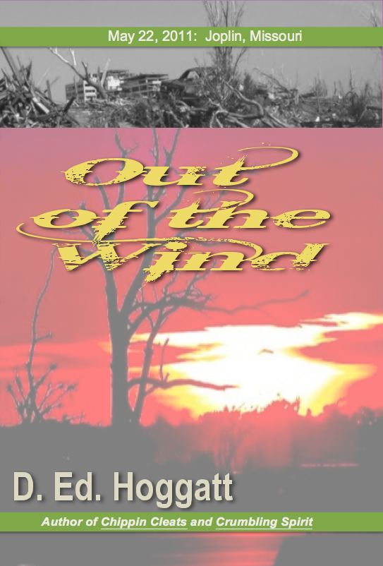
Mr. Hoggatt experienced Oklahoma City’s 1995 terror bombing and Joplin’s 2011 EF5 tornado. Since then, he has written a novel about his experience and observations for readers at the fourth grade level and up.

It is a warm spring day. Graduation just ended. Then suddenly, “This is a tornado warning, in effect for Jasper and Newton Counties…” The deadliest, most damaging tornado in 50 years is about to tear into Joplin, Missouri.

Out of the Wind is a fictionalized story, written from multiple points of view and following the storm and its aftermath. The novel will tug at readers’ emotions and spirit. Follow Carly, Madison, Hailey, Mark, and William on their incredible journey…out of the wind. Readers will feel as if they are experiencing the storm themselves, and yet, the story is appropriately balanced for young readers.

We will order copies of Out of the Wind for Mr. Hoggatt to autograph. If you are interested in a personal copy, please complete this form and send cash to school by [Insert due date].
Student Name ___________________________ Teacher _________________

Number of Copies ($15 each) ________ Total Enclosed _________

